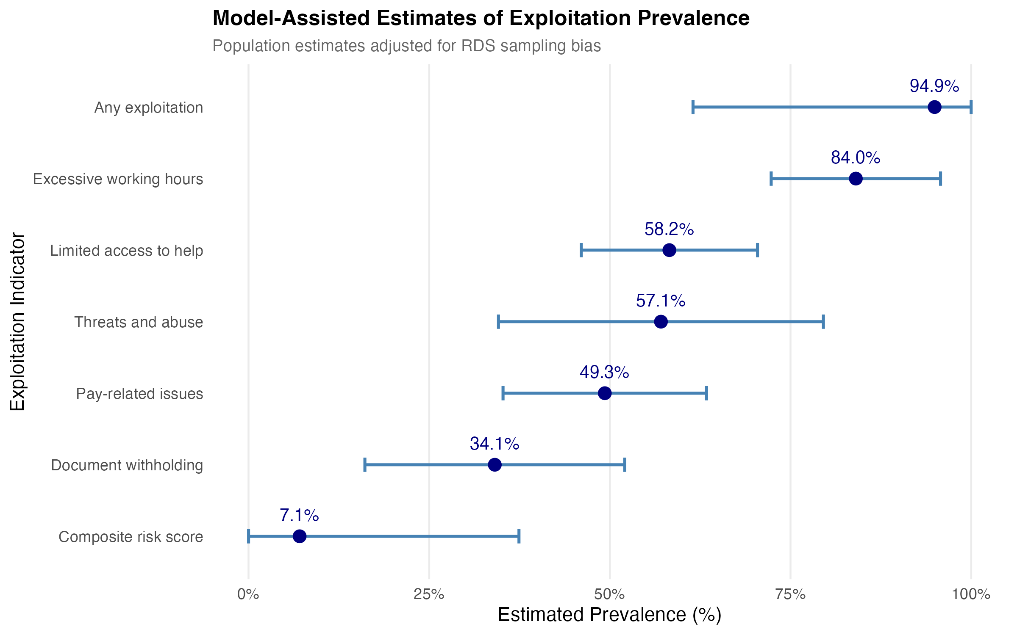
Figure 3. Model-Assisted Estimates of Exploitation Prevalence. Population prevalence estimates with 95% credible intervals for each exploitation indicator, ordered by prevalence magnitude. Posterior intervals are from Bayesian Model-Assisted inference (Gile & Handcock, 2015) at N=50,000 with seed.selection='degree'. Source: Authors' own work.

